ASHE/ECC Sustainability Leads Network meeting

Wednesday 1st October 1.30-3.30pm
Venue: Hamptons Sports and Leisure, Tydemans, Great Baddow CM2 9FH
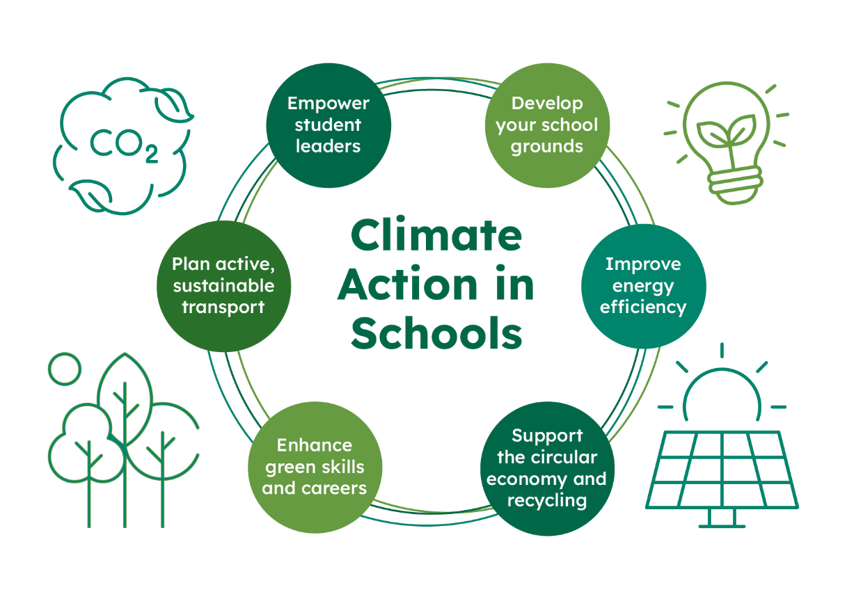
The DfE’s sustainability and climate change strategy for education sets a clear goal: all education settings should have a sustainability lead and a climate action plan. ASHE, ECC and wider teams are working together to provide support for schools.
As well as providing general updates on support for climate action planning, as requested we will be focussing on two key areas during this term’s meeting:
- Developing your school grounds to support climate action and wellbeing
An overview of support from the National Education Nature Park and key ECC teams, including new grants and funding opportunities, alongside examples of successful projects and developments in schools.
A range of agendas will be brought together including support for biodiversity, nature recovery and flood-risk management, alongside wellbeing & mental health, active schools, inclusion and student leadership – as well as teaching & learning!
- Energy efficiency
Detailed guidance on approaching energy efficiency improvements, including quick wins that can lead to substantial financial savings.
To book your place please contact Karen Kerridge on her email address karenkerridge.ashe@gmail.com The cost of the course is £40 to cover room bookings and refreshments.

